|  |  |
| --- | --- |
| Coin Flip is an app that simulates the flipping of a two-sided coin. This app uses App Inventor’s random number generator and two images to simulate the coin flip.  **Objectives**: In this lesson you will learn to:   * create an artifact that uses Randomness and simulates a model; * create a simple model of a coin flipping; * use random number blocks to generate a random value in a specific range; * define a global variable and assign it an initial value; * use a conditional statement, *IF/Else*, to evaluate a variable and follow an algorithm based on the value of a variable; * use a loop to repeat the coin flip many times and calculate the percentage of heads. | screenshotPart1.png  ***[Click to watch Preview Video](http://www.youtube.com/watch?v=5kRDpEl-P-8)*** |

# 

# Getting Ready

Open [App Inventor with the Coin Flip Media Only template](http://ai2.appinventor.mit.edu/?repo=templates.appinventor.mit.edu/trincoll/csp/unit4/templates/CoinFlipMediaOnly/CoinFlipMediaOnly.asc). This will open a project that contains the images you will need in this lesson. Use the *Save As*  option to rename your project to *CoinFlip.*

# The Coin Flip User Interface

The UI for the first version of our Coin Flip app will consist of two *Components:* a *Button* and an Image. The Button is used to flip the coin to either heads or tails. The Image is used to display either heads or tails when the coin is flipped.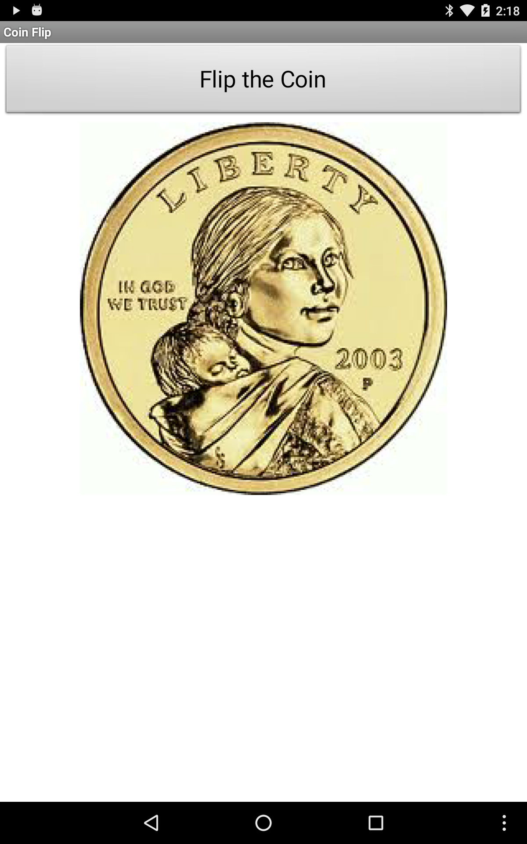

### Adding the Button

1. Get a Button from the Palette’s *User Interface* category
2. Change the text
3. Set the *Width* to Fill Parent

**Adding the Image**

1. Get an Image component from the Palette’s *User Interface* category
2. Change the picture to *heads.jpg* provided in the template
3. To center the image on the screen you can change the *Screen1.AlignHorizontal* property

# Coding the Behavior

# The Coin Flip app should simulate the flipping of a two-sided coin. When the user clicks the button, the coin should be flipped and land on either heads or tails. The picture should change to represent the side the coin lands on. A variable *coin* will be used to represent either heads or tails and an If/Else statement will be used to display the correct image.

### Handling the Button Click Event

Nearly all of the app’s code will be inside the *Button1.Click* event handler. Begin by dragging the *Button1.Click* event handler from the Toolbox onto the Blocks workspace.

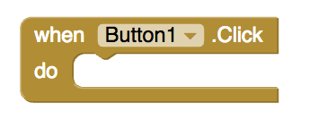

### Coin Variable

How should we represent the coin that is being flipped? The answer, of course, is we will use a global variable.

*Coin* will be a global variable that can have one of two values: 1 (for heads) or 2 (for tails). First initialize the variable by getting an *initialize global variable* block from the Toolbox. Name the variable *coin* and set *coin* to heads by giving it an initial value of 1. Now each time Button1 is clicked, *coin* should ‘flip’ and randomly ‘land’ on 1 (heads) or 2 (tails). To do this, you will need to get a setter block for *coin* from the Toolbox.

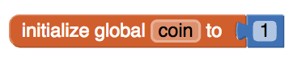

### Simulating the Coin Flip

To randomly set the value of *coin* to be either 1 or 2, you will need to use App Inventor’s *random integer* block. App Inventor has several blocks for randomness in the Toolbox’s *Math* drawer. You may have already seen and used these blocks.

## random fraction: Randomly selects a number (such as 0.532) between 0 and 1 (not including 1):

4.4RandomFractionBlock.PNG

## random integer: Randomly selects a number between two specified whole numbers, inclusive:

4.4RandomIntegerBlock.PNG

Because our *coin* will have a random whole number (1 or 2), we will use the second of these blocks.

Get the *random integer* block from the Toolbox and use it to set the value of the *coin* variable. Then, specify the range to be from 1 to 2 using the number blocks that are provided. This code should go inside the *Button1.Click* handler:

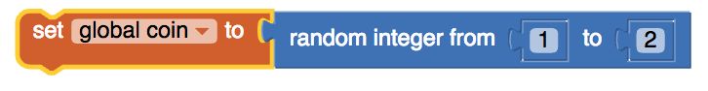

Now, if you were to click the button, *coin* would ‘flip’ and randomly ‘land’ on 1 (heads) or 2 (tails) but you would only see the heads.jpg image on your screen. Let’s use an If/Else statement to determine when *heads.jpg* should be shown and when *tails.jpg* should be shown.

**Displaying the Result: If/Else Algorithm**

To display the result of the simulated coin flip, we will either display the *heads.jpg* image or the *tails.jpg* image. For this, we will need an *if/else* block that implements the pseudocode algorithm shown on the left in the following table, with the corresponding App Inventor code shown on the right.

|  |  |
| --- | --- |
| **IF (coin = 1)**  **{**  **DISPLAY( heads.jpg )**  **}**  **ELSE**  **{**  **DISPLAY( tails.jpg )**  **}** | IfCoinEq1.png |

### Coin Flip Simulation Algorithm

Putting these elements together gives us the following algorithm for simulating the flipping of a two-sided coin, both in College Board-style pseudocode and in App Inventor blocks.

|  |  |
| --- | --- |
| **WHEN Button1.Click**  **{**  **coin ← RANDOM(1,2)**  **IF (coin = 1)**  **{**  **DISPLAY( heads.jpg )**  **}**  **ELSE**  **{**  **DISPLAY( tails.jpg )**  **}**  **}** | WhenButtonFlip.png |

### Testing the App

Now, you have a fully functioning Coin Flip app that simulates the flipping of a two-sided coin. Test out your app to make sure it works correctly. How accurately can you predict whether the next ‘flip’ will be heads or tails? If you can’t predict any more accurately than flipping a real coin, then we have created a pretty good *computer* *model* or *computer* *simulation* of a coin flip.

# How Does a Computer Model Randomness

App Inventor -- and other computer languages -- use a form of randomness called ***pseudo randomness.*** Pseudo randomness is a model (or simulation) of true randomness. Just like your app models or simulates a coin flip, the App Inventor blocks *random-fraction* and *random-integer,* which we used to generate random numbers, are models or simulations of truly random numbers. In fact, there are algorithms in App Inventor, known as Pseudo Random Number Generators or PRNGs, that simulate the generation of random numbers. We will take a closer look at how PRNGs work in an upcoming lesson.

As we will learn later in the course when talk about encryption, the development of secure networks -- such as the Internet -- depends in crucial ways on the development of good PRNGs. So this is an important area of research in computer science and related fields of mathematics.

# Repeating the Coin Flip

Now that we know how to model a coin flip, let’s create another app that will let us perform the following ***modeling experiment:***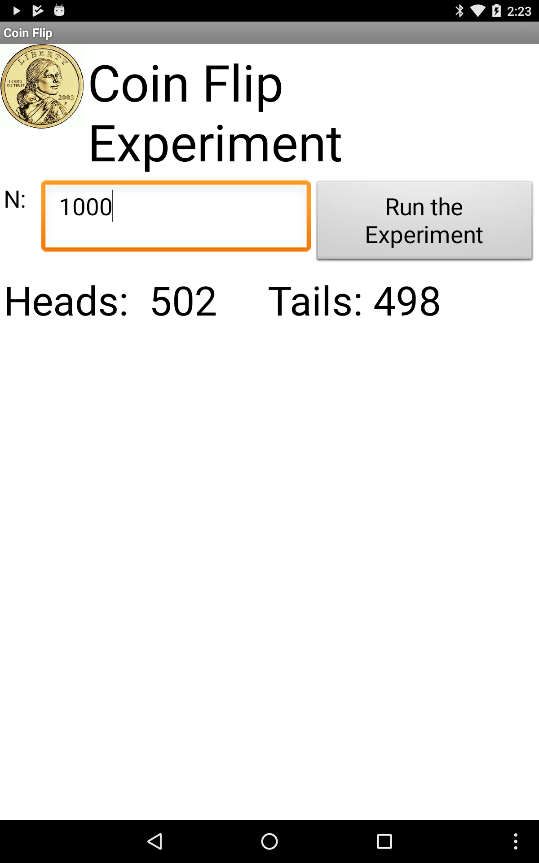

Let the user input a number, *N,* and press a “Run Experiment” button that will cause the app to simulate *N* coin flips and report the number of heads and the number of tails.

If we did this experiment with a real (fair) coin, we would expect to get roughly 50% heads.

If App Inventor’s ***random-integer*** function is well designed, we should similarly expect to get roughly 50% heads when we perform this simulation experiment.

### 

### 

### 

### Rename the App

To begin with, let’s rename our app to *CoinFlipExperiment* (using Projects > Save As).

### Revise the UI.

Let’s revise the UI so it looks like this:

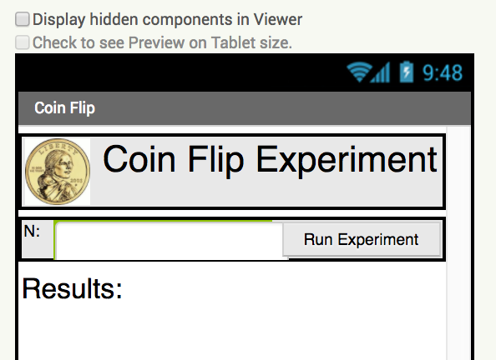

* Add a *HorizontalArrangment* at the very top of the screen. Then add the coin *Image* to the arrangement followed by a Label named *LabelTitle.* Set the image’s width and height to 50 pixels and the title’s font size to 30. The title label should be labelled “Coin Flip Experiment.”
* Add another *HorizontalArrangement* just below the first one and then add a *Label* and a *TextBox* to it. This Label should be named *LabelN* and labeled “N:” and the TextBox should be named *TextBoxN* and have its *NumbersOnly* property set to true (checked).
* Change the name of *Button1* to *ButtonGo* and its label to “Run Experiment” and add it to the right hand side of the HorizontalArrangement.
* Add another label named*LabelResults* below the horizontal arrangements and label it “Results”. Set its font to 24. This is where we will display the results of the experiment.

### Experiment Variables

Clearly we’re going to need some additional variables to manage the experiment. Add the following variables to the app:

* N - initialize N to 0. This will be the number of coin flips based on the user’s input in the TextBox.
* nHeads - initialized to 0. We’ll use this variable to count the number of heads in the experiment.

### Coding the Loop

What kind of problem are we using the loop to solve? Basically, if the user inputs 100 we want to flip the coin 100 times and on each flip we want to test whether it comes up heads or tails. This is a ***counting problem*** -- i.e, we need to count the coin flips, starting at 1 and stopping at 100. More generally, we need to count from 1 to N (whatever the user input). The best loop for this kind of problem is App Inventor’s ***For each number from __ to __ by __*** loop, where the __’s are place holders.

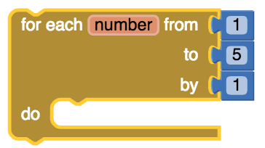

In our case, we want to replace the 5 by N, the total number of coin flips to perform:

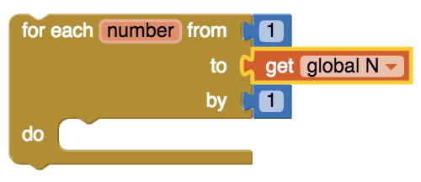

Theloop will repeatedly perform whatever operations we put inside its ***do*** slot.

### Before the Loop: Initializations

When you’re coding a loop, it is necessary to perform some ***initialization steps.*** In this case we need to set the value of ***N,*** which will control when the loop will stop or. This variable will be initialized by taking the value the user inputs into the TextBox. And we need to initialize ***nHeads*** to 0 -- because, as we’re going to be counting the number of heads we get, we want to start counting at 0:

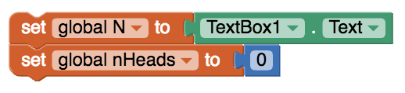

### The Body of The Loop: N Coin Flips

What needs to be done in the ***body*** of the loop -- i.e., in the ***do*** slot? We need to “flip” the coin and then count whether it came out heads or tails. We already know how to do this using the ***random integer*** block for the coin flip and an ***if/else*** for checking whether it’s heads or tails. In this case, however, rather than displaying a heads or tails image, we’re going to add 1 to the ***nHeads***variable.

### ForNCoinFlip.png

### After the Loop: Report Results

When the loop finishes, we will report the results in the *LabelResults.* Here’s the format we will use:

Heads: 52 Tails: 48

We can do this by using ***string concatenation*** (the join block) as follows:

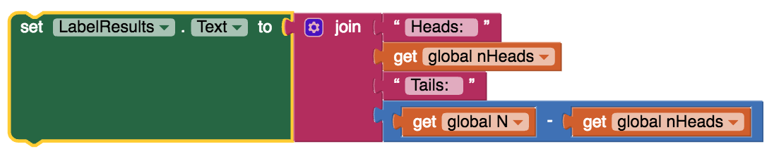

Notice here that the number of tails is calculated by simply subtracting the *nHeads* from *N.*

### The Whole Algorithm

All of these steps are combined into a single algorithm in the *ButtonGo.Click* event handler, as shown in the following table in both App Inventor and pseudocode. (**NOTE** that College Board style pseudocode does not contain a ***For each number from 1 to N*** loop. Instead we use its ***REPEAT N times*** loop, which is equivalent in this case.)

|  |
| --- |
| **Pseudocode**  **WHEN ButtonGo.Click**  **{**  **N ← INPUT()**  **nHeads ← 0**  **REPEAT N TIMES**  **{**  **coin ← RANDOM(1,2)**  **IF (coin = 1)**  **{**  **nHeads ← nHeads + 1**  **}**  **}**  **DISPLAY( “Heads:”, nHeads,” Tails:”, (N - nHeads) )**  **}** |
| WhenGo.png |

### Running and Testing the App

If you have coded the app as shown here, then whenever *ButtonGo* the app will perform one trial of the experiment consisting of *N* simulated coin flips. Try varying the value for N -- you can try 100, or 1000, or 10,000 or any other value. **NOTE: Be careful with very large values of *N* -- that might take a long time causing your device to become unresponsive, which may even generate a runtime error message from Android.**

In the next lesson, we’re going to use this app to run an experiment designed to test the validity of App Inventor’s *random integer* block.

# Reflection for the Student

In your portfolio, create a new page named ***Coin Flip*** and answer the following questions:

1. Write an **if/else** statement to express the following real life situation. Mary likes ice cream and always chooses chocolate unless there is no chocolate in which case she chooses strawberry. But if there’s no strawberry either then she settles for vanilla, which, for some reason, is always available.
2. We didn’t need it for the loop in this lesson, but the ***number*** element in the ***For each number*** loop is a local variable whose value changes automatically on each iteration of the loop. For example, in this loop ***number*** would start at 1 and then go to 2, 3 and 4. And this value can be used in the body of the loop, as shown in this example. Given that, trace through this loop and figure out what value global ***sum*** would have when the loop finishes.
3. App Inventor’s random-integer block is an abstract ***model of randomness*** -- i.e., an *abstraction* of real randomness such as flipping a *real* coin. What would you say about the random-integer block if you ran the coin flipping simulation 10,000 times and the result was that it came up heads 55% of the time?

***Nice work! Complete the Self-Check Exercises and Portfolio Reflection Questions as directed by your instructor.***